**LEBANESE AMERICAN UNIVERSITY**

**USAID – HIGHER EDUCATION SCHOLARSHIP PROGRAM**

**HES - Volunteering Program Verification Form**

This form is to be used to document volunteering hours. If a student volunteers for multiple organizations, a separate form must be used for each organization. **This form must be turned in by the 28th of each month, the latest.**

I certify that the scholar Nadine Dagher completed a total of 5 hours of service at InnovaThrive.

The hours were completed hours as per the below:

Hours # 0 (date) _2/12 – 6/12_ (initials of supervisor) __A.K.___

Hours # 0 (date) _9/12 – 13/12_ (initials of supervisor) __A.K.___

Hours # 0 date) _16/12 – 20/12 (initials of supervisor) __A.K.___

Hours # 5 date) _23/12 - 27/12 (initials of supervisor) __A.K.___

Brief description of the activities the scholar performed or participated in:

I wrote a paper about the psychological impacts of virtual influencers and discussed the:  
Applications:  
Advertising campaigns led by virtual influencers.  
Virtual celebrities driving brand engagement.  
Statistics  
: Rising popularity of virtual influencers, with a 50% growth in audience engagement compared to traditional influencers.  
  
Advantages:  
Creative flexibility for brands.  
Disadvantages:  
Ethical concerns regarding audience manipulation.  
Challenges:  
Balancing transparency in virtual influencer marketing.  
  
Future Research:  
Exploring long-term psychological effects on younger audiences.  
AI for detecting and regulating harmful content from virtual influencers

Written feedback about the scholar’s performance:

Nadine Dagher’s paper on the psychological impacts of virtual influencers demonstrated strong research and analytical skills. However, her volunteering form was submitted late. This delay is unacceptable, as timely submissions are essential for the smooth operation of the program. It is expected that all future forms will be submitted by the deadline.

Please rate the overall performance of the scholar at your organization:

|  |  |  |  |
| --- | --- | --- | --- |
|  | Mastery (5) | Proficient (3) | Emerging (1) |
| **Problem solver** | X |  |  |
| **Engaged & Committed** | X |  |  |
| **Open-minded & multicultural** | X |  |  |

Signature

& stamp

__________________________

_

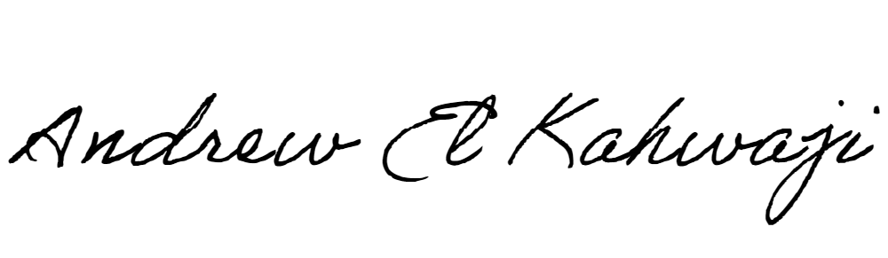

Printed Name _Andrew El Kahwaji_

Date __26/12/2024___

Email __andrew.lifesculptor.coo@gmail.com __

Phone __+961 71 914 378__